MOBILE PHONE DETECTOR

*A Mini Project Report submitted in partial fulfilment of the requirement for the award of the Degree of*

**BACHELOR OF TECHNOLOGY**

*In*

**ELECTRONICS AND COMMUNICATION ENGINEERING**

*By*

19JG1A0465 - N.MEGHANA

19JG1A0470 - O.VIDYARANI

19JG1A04A1 - T.YESHASWANI SREEJA

20JG1A0409 - K.RAJYALAKSHMI



Under the Esteemed guidance of

Mrs B. Lakshmi

Assistant Professor

**DEPARTMENT OF ELECTRONICS AND COMMUNICATION ENGINEERING**

**GAYATRI VIDYA PARISHAD COLLEGE OF ENGINEERING FOR WOMEN**

*(Affiliated to Jawaharlal Nehru Technological University, Kakinada)*

**MADHURAWADA, VISAKHAPATNAM-48**

**(2019-2022)**

**GAYATRI VIDYA PARISHAD**

**COLLEGE OF ENGINEERING FOR WOMEN**

**DEPARTMENT OF ELECTRONICS AND COMMUNICATION ENGINEERING**



# **CERTIFICATE**

This is to certify that the mini project titled **“Mobile Phone Detector”**is a bonafide work of the following III B-Tech students in the Department of Electronics and Communication Engineering during the academic year 2021-22, in partial fulfillment of the requirement for the award of the degree of Bachelor of Technology under Jawaharlal Nehru Technological University, Kakinada.

N . Meghana (19JG1A0465)

O . Vidyarani (19JG1A0470)

T . Yeshaswani Sreeja (19JG1A04A1)

K . Rajyalakshmi ( 20JG1A0409)

**Project Supervisor Head of the Department**

**(Mrs.B.Lakshmi) (Dr. K. Srinivasa Rao)**

**External Examiner**

# **ACKNOWLEDGEMENT**

We sincerely thank our project guide Mrs.B.Lakshmi , Assistant professor for her guidance and constant encouragement to us at every stage and aspect by including the spirit of understanding and support in carrying out our main project at college.

We would like to express sincere thanks to our Head of the Department of Electronics and Communication Engineering **Dr. K. Srinivasa Rao** for his valuable suggestions and constant motivation that greatly helped me in completing the project work successfully.

We express sincere thanks to our Vice Principal, Professor **Dr. G. Sudheer,** for his encouragement and co-operation in completion of our project.

We wish to express our deep sense of our gratitude to our Principal, Professor **Dr. R. K. Goswami**, for giving us the opportunity to carry out the project work successfully.

We would like to express our gratitude towards our parents & members of Gayatri Vidya Parishad College of Engineering for Women for their kind co-operation and encouragement which helped us in completion of our project.

N.Meghana(19jg1a0465)

O.Vidyarani(19jg1a0470)

T.YeshaswaniSreeja(19jg1a04a1)

K.Rajyalakshmi(20jg1a0409)

ABSTRACT

This handy , pocket-size mobile transmission detector or sniffer can sense the presence of an activated mobile cell phone from a distance of one and-a-half meters . So it can be used to prevent use of mobile phones in examination halls , confidential rooms, etc.. It is also useful for detecting the use of mobile phone for Spying and unauthorized video transmission .The circuit can detect the incoming and outgoing calls, SMS and video transmission even if the mobile phone is kept in the silent mode . The moment the Bug detects RF transmission signal from an activated mobile phone , it starts sounding a beep alarm and the LED blinks. The alarm continues until the signal transmission ceases .Assemble the circuit on a general purpose PCB as compact as possible and enclose in a small box like junk mobile case . As mentioned earlier , capacitor C3 should have a lead length of 18mm with lead spacing of 8mm . Carefully solder the capacitor in standing position with equal spacing of the leads. The response can be optimized by trimming the lead length of C3 for the desired frequency . You may use a short telescopic type antenna. Use the miniature12V battery of a remote control and a small buzzer to make the gadget pocket-size . The unit will give the warning indication if someone uses Mobile phone within a radius of 1.5meters

ACRONYMS AND ABBREVIATIONS

• GSM – Global System for Mobile

• RF – Radio Frequency

• AM – Amplitude Modulation

• FM – Frequency Modulation

• LED – Light Emitting Diode

• BJT – Bipolar Junction Transistor

• UJT – Unipolar Junction Transistor

• FET – Field Effect Transistor

• JFET – Junction Field Effect Transistor

• MOSFET - Metal Oxide Semiconductor Field Effect Transistor

• CMOS – Complementary Metal Oxide Semiconductor

• TTL - Transistor-TransistorLogic

• OP-AMP – OperationalAmplifier

• UHF – Ultra High Frequency

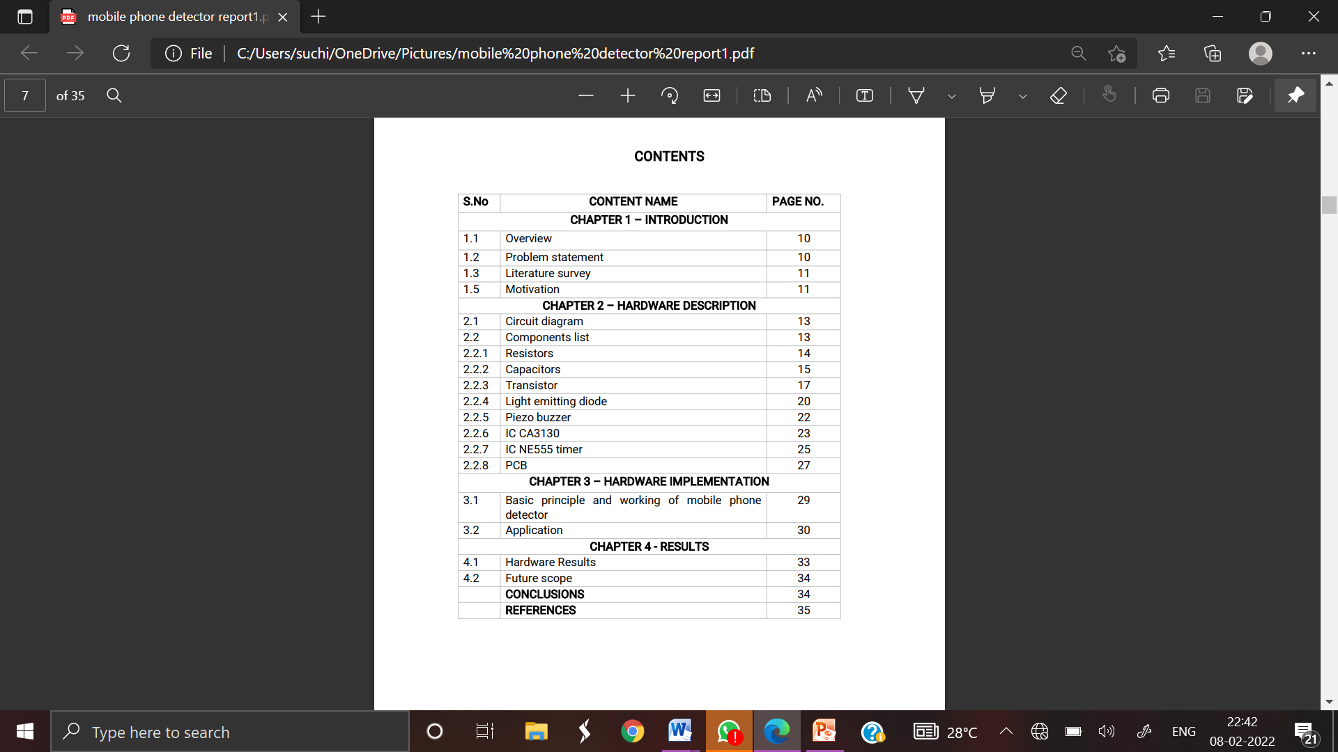

CHAPTER : 1

INTRODUCTION

**1.INTRODUCTION**

**1.1 Overview**

As increase in the technology in the world using the electronic equipments are being used in a wrong way like ,in the examination halls and confidential rooms . To avoid this we are introducing a project called CELLPHONEDETECTOR. This handy , pocket-size mobile transmission detector or sniffer can sense the presence of an activated mobile cell phone from a distance of one and- a-half meters . So it can be used to prevent use of mobile phones in examination halls , confidential rooms, etc.It is also useful for detecting the use of mobile phone for Spying and unauthorized video transmission .The circuit can detect the incoming and outgoing calls , SMS and video transmission even if the mobile phone is kept in the silent mode. The moment the Bug detects RF transmission signal from an activated mobile phone, it starts sounding a beep alarm and the LED blinks. The alarm continues until the signal transmission ceases.

**1.2 Problem Statement**

Previously , there was no technology to detect the cell phones in the examination hall and in cell phone restricted areas .There is manual checking and there is still a chance of having the cell phone with the person if he is not checked properly .So to avoid this problem, an automatic detection of cell phone is introduced.

**1.3 Literature Survey**

The existing technology currently available in the open market utilizes mostly discrete components , and a design approach using a down converter in conjunction with a band pass filter .The technologies are not adequate because they are in accurate and expensive. The first signal detection technique , an RF detector using tuned InductorCapacitor(LC) utilizes discrete components which is difficult to implement. They are very affordable to construct , but requires precision tuning . This design when analysed was found to be in accurate .The design in corporated tuned LC circuit which is used to detect low frequency radiation in the Amplitude Modulation (AM) and Frequency Modulation (FM)bands . It detects signals in the GHz frequency band used in mobile phones as the transmission frequency of mobile phone ranges from 0.9 to 3GHz . A capacitor is used to form a part of the LC circuit as C while the lead(coiled wire)of the same forms the L to receive RF signals from the mobile phone .

When the mobile phone is activated the RF transmission signal is detected by the detector and starts sounding a beep alarm and the LED blinks. The second technique seems to be accurate but has its own short comings, in addition to being very expensive. The two most popular mobile phone detectors available under this technology are produced by Berkeley Varitronics Systems and mobile Security products. These companies produce the wolfhound cell phone detector and cell buster ,respectively. The Berkeley Varitronics systems Wolf hound cell phone detects PersonalComputers(PCs),CodeDivisionMultipleAccess(CDMA),GlobalSystem for Mobiles(GSM) and cellular bands using the RFsignals.It is also capable to directionally find and locate cellular phones that are nearby. The Wolfhound seems to be a great way to detect cellular phones but may just randomly detect mobile phone communications in the area and not necessarily the Phone or device that set it off. The Cell Buster from mobile security product which provides continuous monitoring for mobile phone and has voice alert that tells the user to shut their phone off if detected . The Cell Buster only receives and does not transmit, making it great for areas that are sensitive to cellular phone usage . It also detects phones that are in stand by mode. The Cell Buster also seems like it would work wonderfully for keeping people from bringing their phones into restricted areas , however ,like the Berkeley Vantronics systems it has its short comings as it takes upto 20minutes to detect if it is in stand by and that the phone needs to be on and its detection could be random transmission in that area

**1.4 Motivation**

Cell phones are used in good way and also in a bad way . When the class is going on , students intend to use their cell phones and not listening to what is being taught .These days , students are also carrying their cell phones to the examination halls to copy which would help them to get good marks. To avoid this problem , the cell phone detector is introduced.

CHAPTER-2

HARDWARE DESCRIPTION

**2.HARDWARE DESCRIPTION**

**2.1Circuitdiagram**

CELL PHONE DETECTOR

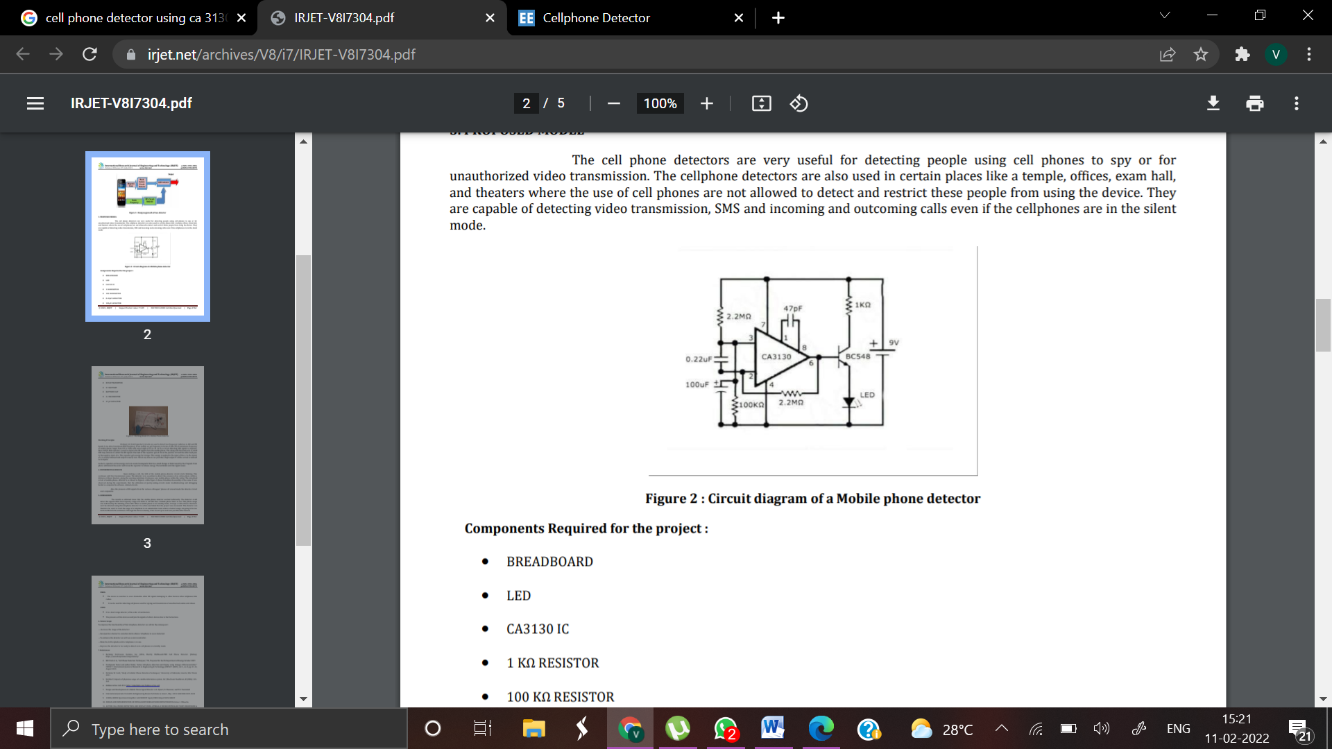

Fig 2.a Circuit Diagram

**2.2 Components List:**

•RESISTOR

1.R1-2.2M Ohm

2.R2-100K Ohm

3.R3 - 1K Ohm

•CAPACITOR

4.C1 - 0.22µF

5.C2 - 100µF

6.C3 - 47pF

•IC

7..ICCA3130

•TRANSISTOR

8.BC548

9.LED

10.ANTENNA   
11.5INCHLONGANTENNA

12.BATTERY AND ITS CLIP

13..BREAD BOARD

14.CONNECTING WIRES

**2.2.1RESISTOR**

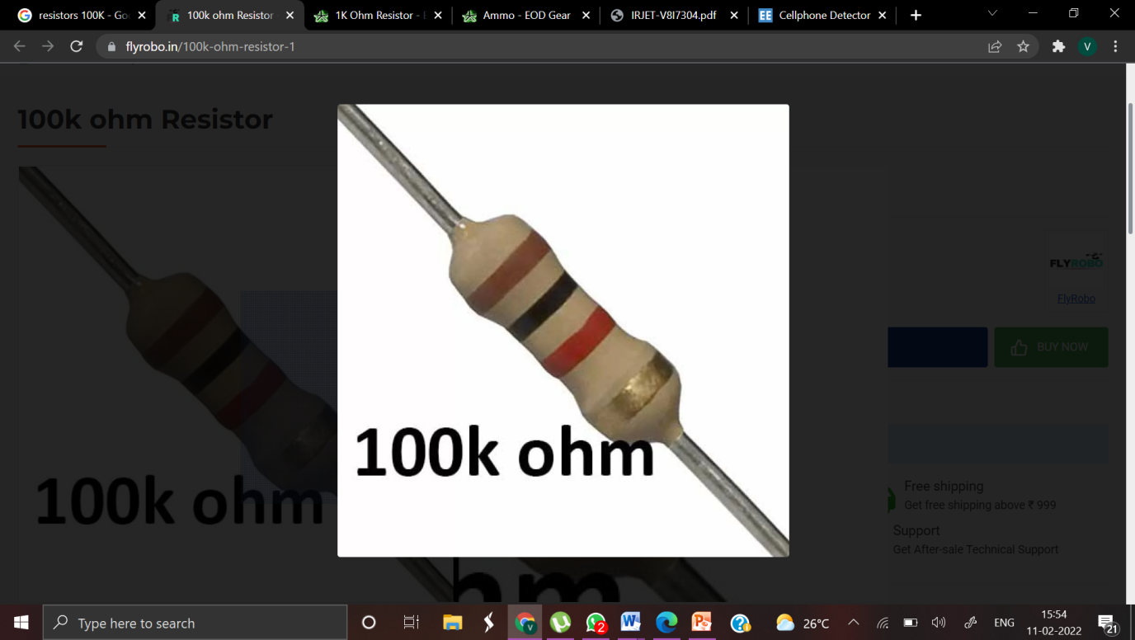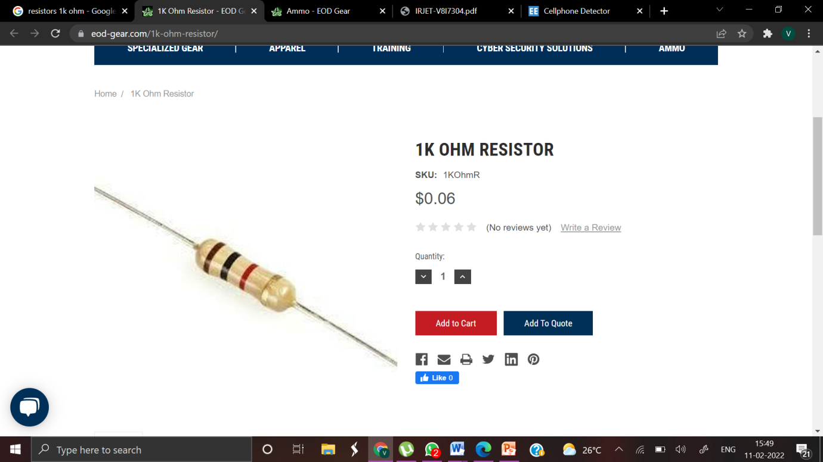

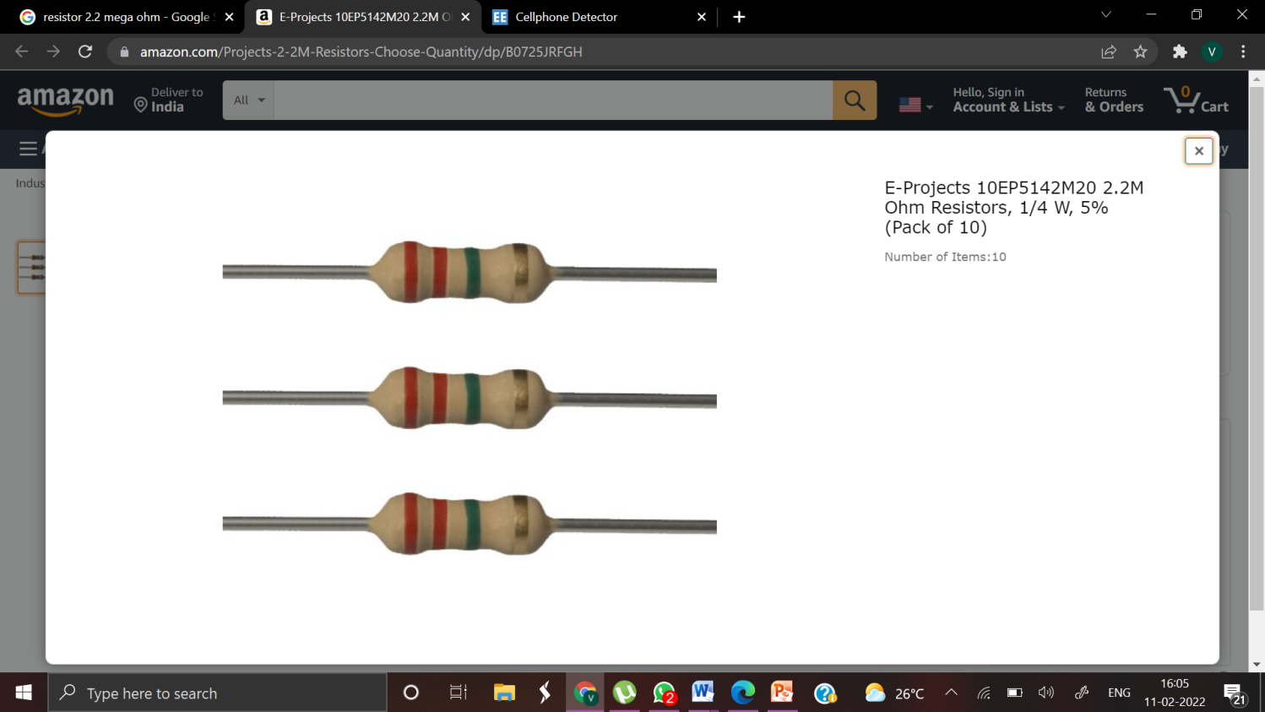2.2 M ohm

Fig.:2.bResistor

A resistor is a two-terminal electronic component that produces a voltage across its terminals that is proportional to the electric current through it in accordance with Ohm's law: V=IR Resistors are elements of electrical networks and electronic circuits and are ubiquitous in most electronic equipment.

Practical resistors can be made of various compounds and films , as well as resistance wire (wire made of a high-resistivity alloy, such as nickel/chrome). The primary characteristics of a resistor are the resistance , the tolerance ,maximum working voltage and the power rating. Other characteristics include temperature coefficient , noise , and inductance. Less well-known is critical resistance ,the value below which power dissipation limits the maximum permitted current flow, and above which the limit is applied voltage. Critical resistance depends upon the materials constitute the resistor as well as its physical dimensions ; it's determined by design . Resistors can be integrated into hybrid and printed circuits, as well as integrated circuits. Size and position of leads(or terminals) are relevant to equipment designers; resistors must be physically large enough not to over heat when dissipating their power.

**2.2.2CAPACITORS**

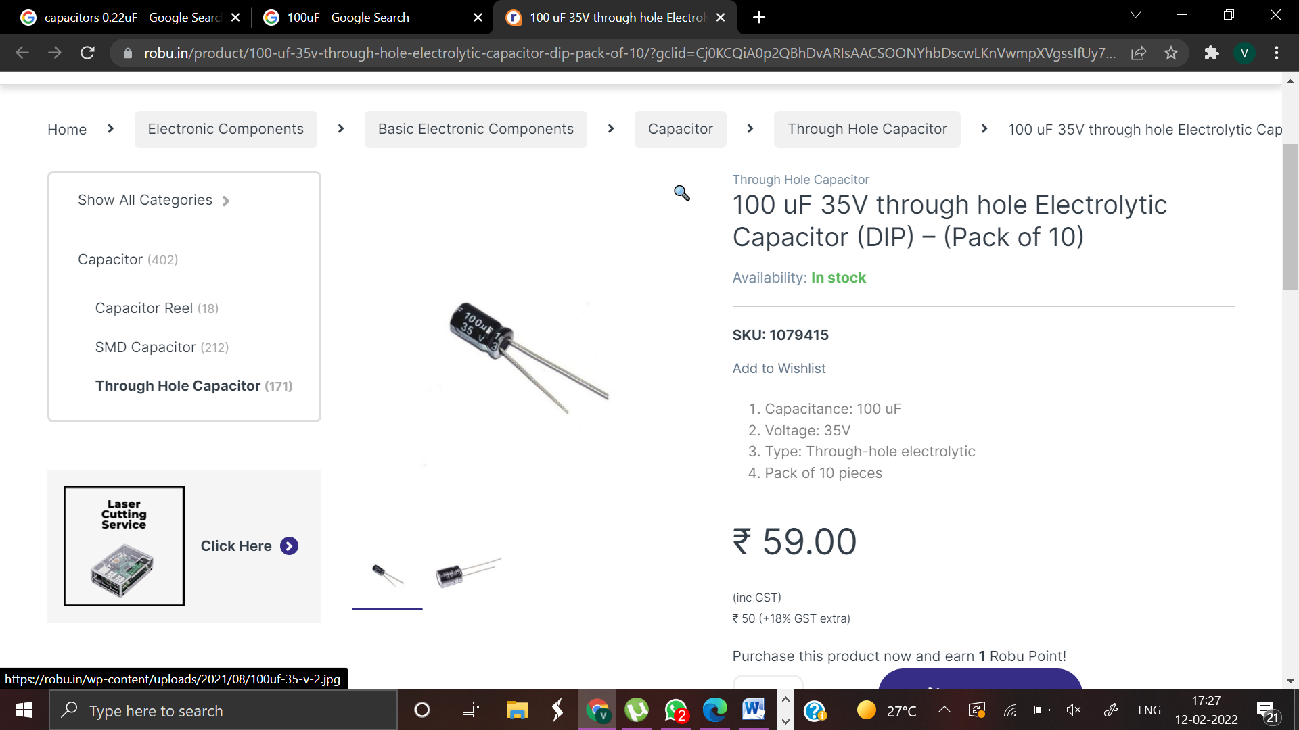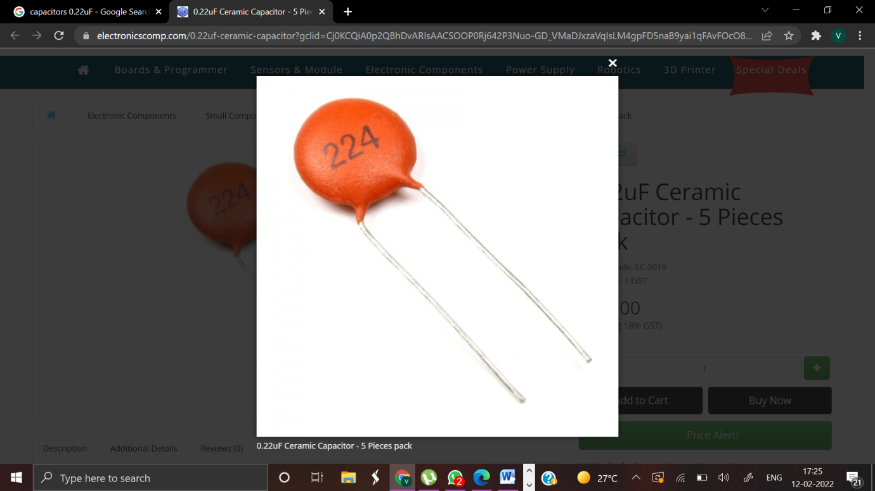

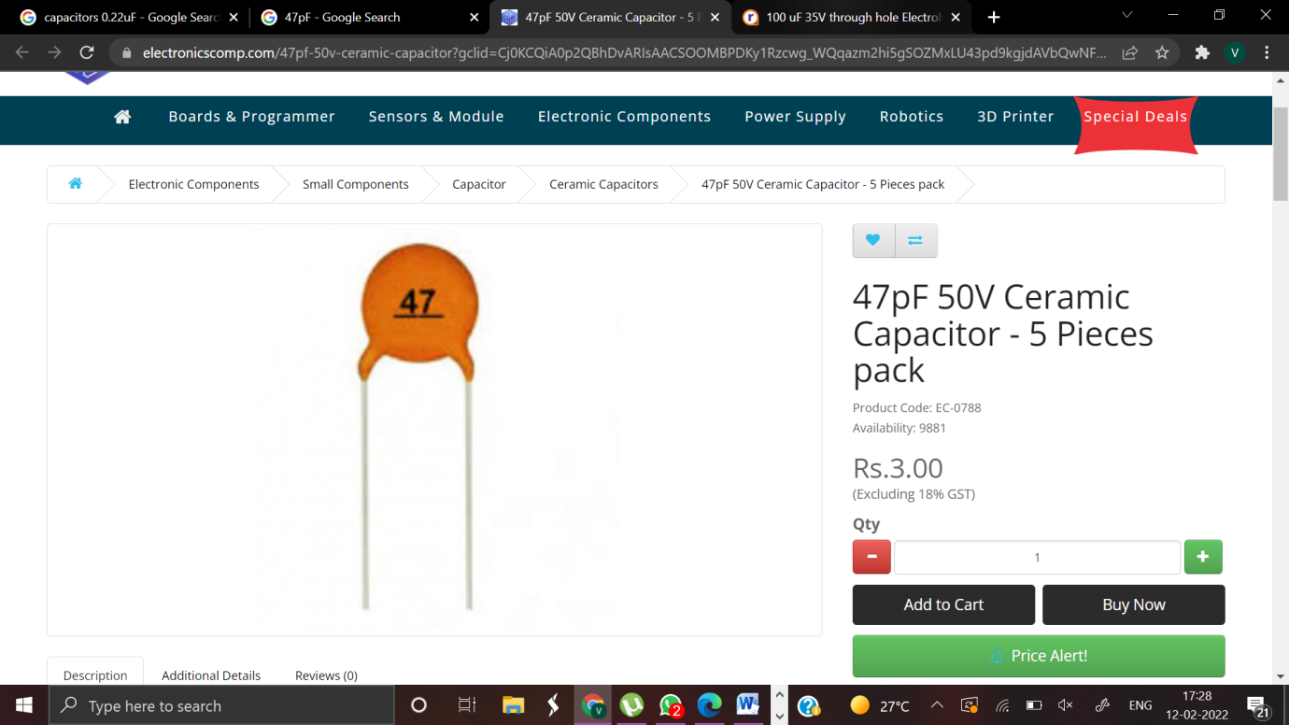

Fig.:2. Capacitors

A capacitor or condenser is a passive electronic component consisting of a pair of conductors separated by a dielectric. When a voltage potential difference exists between the conductors ,an electric field is present in the dielectric .This field stores energy and produces a mechanical force between the plates .The effect is greatest between wide , flat , parallel , narrowly separated conductors . An ideal capacitor is characterized by a single constant value, capacitance ,which is measured in farads .This is the ratio of the electric charge on each conductor to the potential difference between them. In practice ,the dielectric between the plates passes a small amount of leakage current . The conductors and leads introduce an equivalent series resistance and the dielectric has an electric field strength limit resulting in a break down voltage . Capacitors are widely used in electronic circuits to block the flow of direct current while allowing alternating current to pass , to filter out interference , to smooth the output of power supplies , and form any other purposes .They are used in resonant circuits in radio frequency equipment to select particular frequencies from a signal with many frequencies

**1) CERAMIC CAPACITOR**



Fig.:2.c-1 Ceramic Capacitor

In electronics ceramic capacitor is a capacitor constructed of alternating layers of metal and ceramic ,with the ceramic material acting as the dielectric .The temperature coefficient depends on whether the dielectric Class1 or Class2.A ceramic capacitor (especiallytheclass2) often has high dissipation factor , high frequency coefficient of dissipation

A ceramic capacitor is a two-terminal ,non-polar device . The classical ceramic capacitor is the "disc capacitor". This device pre-dates the transistor and was used extensively in vacuum-tube equipment (e.g., radio receivers) from about 1930 through the 1950s, and in discrete transistor equipment from the 1950s through the 1980s. As of 2007, ceramic disc capacitors are in wide spread use in electronic equipment, providing high capacity & small size at low price compared to other low value capacitor types. Ceramic capacitors come in various shapes and styles, including:

•disc, resin coated , with through – hole leads •multilayer rectangular block , surface mount •bare lead less disc, sits in a slot in the PCB and is soldered in place , used for UHF applications •tube shape , not popular now

**2) ELECTROLYTIC CAPACITOR**

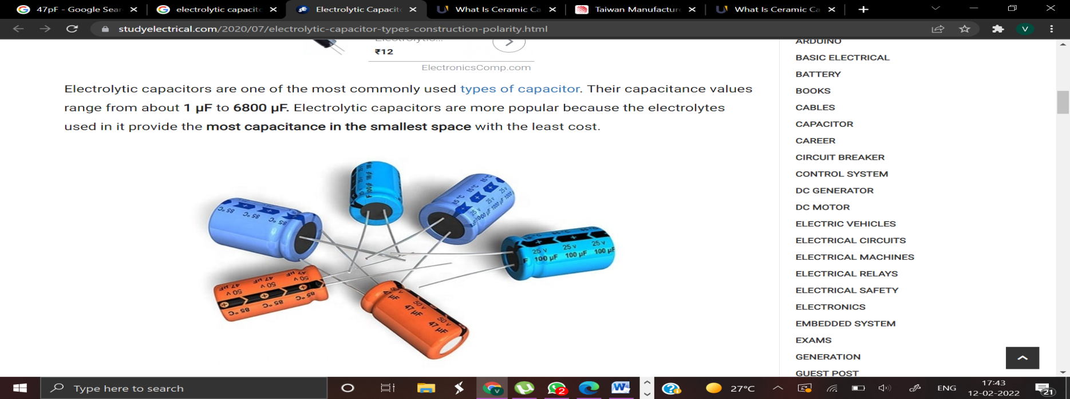

Fig.:2.c-2Electrolyticcapacitor

Axial lead (top) and radial lead (bottom) electrolytic capacitors An electrolytic capacitor is a type of capacitor that uses an ionic conducting liquid as one of its plates with a larger capacitance per unit volume than other types . They are valuable in relatively high-current and low-frequency electrical circuits . This is especially the case in power-supply filters ,where they store charge needed to moderate output voltage and current fluctuations in rectifier output .They are also widely used as coupling capacitors in circuits where AC should be conducted but DC should not .Electrolytic capacitors can have a very high capacitance ,allowing filters made with them to have very low corner frequencies

**2.2.3 TRANSISTOR**

A transistor is a semiconductor device commonly used to amplify or switch electronic signals .A transistor is made of a solid piece of a semiconductor material ,with at least three terminals for connection to an external circuit .A voltage or current applied to one pair of the transistor's terminals changes the current flowing through another pair of terminals. Because the controlled(output) power can be much more than the controlling (input)power, the transistor provides amplification of a signal .Some transistors are packaged individually but most are found in integrated circuits .The transistor is the fundamental building block of modern electronic devices ,and its presence is ubiquitous in modern electronic systems.

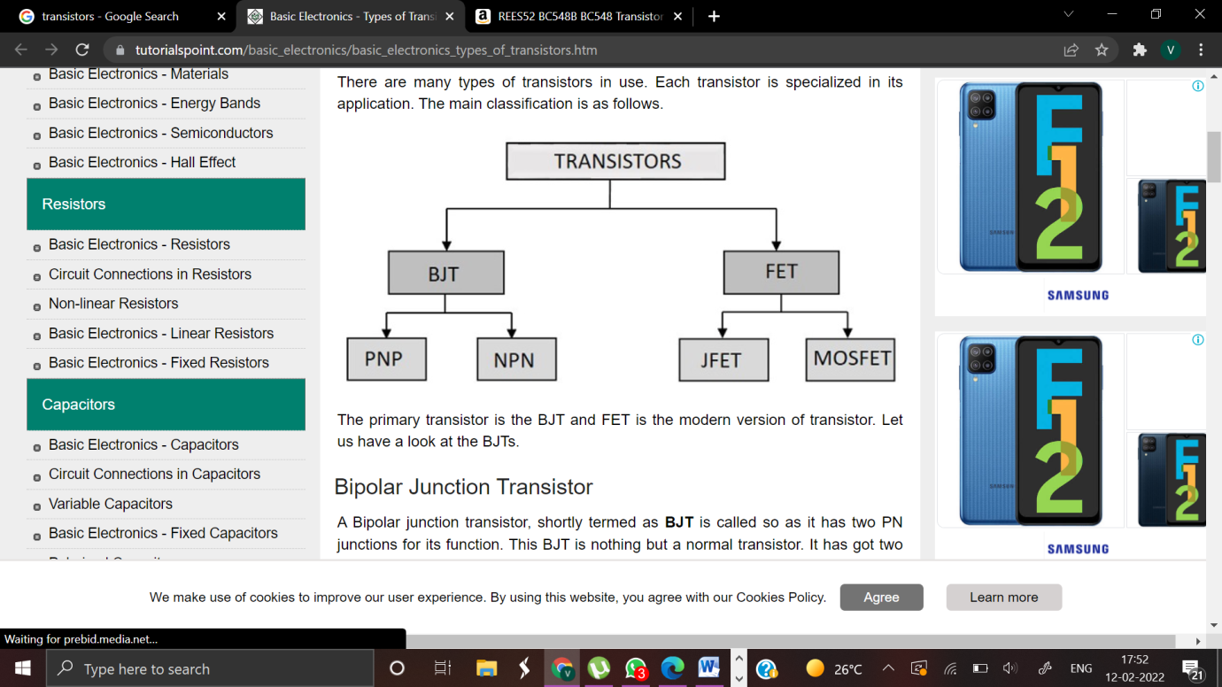  
 Fig.:2.dTransistor Classification

USAGE:

The bipolar junction transistor ,or BJT ,was the most commonly used transistor in the1960s and 70s.Even after MOSFETs became widely available, the BJT remained the transistor of choice for many analog circuits such as simple amplifiers because of their greater linearity and ease of manufacture. Desirable properties of MOSFETs , such as their utility in low-power devices, usually in the CMOS configuration , allowed them to capture nearly all market share for digital circuits ; more recently MOSFET shave captured most analog and power applications as well , including modern clocked analog circuits, voltage regulators, amplifiers, power transmitters, motor drivers, etc ADVANTAGES:

The key advantages that have allowed transistors to replace their vacuum tube predecessors in most applications are •Small size and minimal weight, allowing the development of miniaturized electronic devices.• Highly automated manufacturing processes, resulting in low per-unit cost.• Lower possible operating voltages, making transistors suitable for small, batterypowered applications.• Now arm-up period for cathode heaters required after power application •Lower power dissipation and generally greater energy efficiency.• Hig­her reliability and greater physical ruggedness. Extremely long life. Some transistorized devices have been in service for more than 30years. •Complementary devices available, facilitating the design of complementarysymmetry circuits, something not possible with vacuum tubes. • Insensitivity to mechanical shock and vibration, thus avoiding the problem of micro phonics in audio applications.

LIMITATIONS:

Silicon transistors do not operate at voltages higher than about 1,000 volts (SiC devices can be operated as high as 3,000volts) .In contrast ,electron tubes have been developed that can be operated at tens of thousands of volts. •High power , high frequency operation , such as used in over-the – air television broadcasting, is better achieved in electron tubes due to improved electron mobility in a vacuum. •On average , a higher degree of amplification linearity can be achieved in electron tubes as compared to equivalent solid state devices , a characteristic that may be important in high fidelity audio reproduction. •Silicon transistors are much more sensitive than electron tubes to an electromagnetic pulse ,such as generated by an atmospheric nuclear explosion

TYPE: Bipolar Junction Transistor

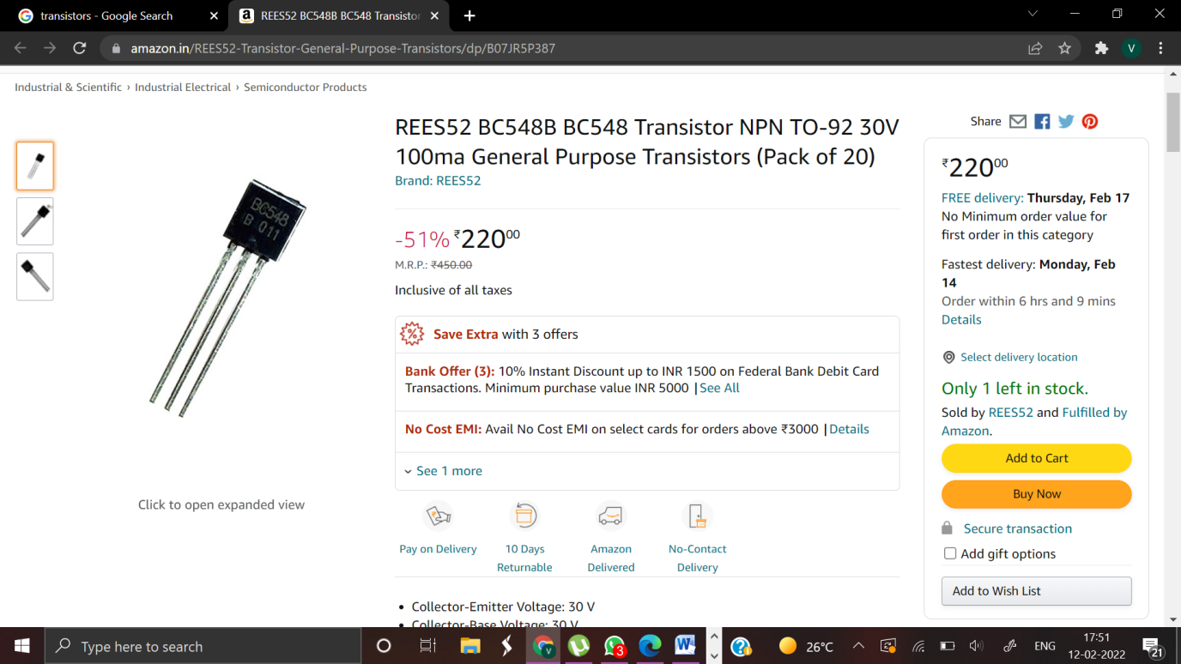  
 Fig.:2.d-1 BC548

The bipolar junction transistor(BJT) was the first type of transistor to be mass-produced. Bipolar transistors are so named because they conduct by using both majority and minority carriers. The three terminals of the BJT are named emitter, base, and collector. The BJT consists of two p-n junctions : the base–emitter junction and the base–collector junction, separated by a thin region of semiconductor known as the base region (two junction diodes wired together without sharing an intervening semiconducting region will not make a transistor)."The [BJT] is useful in amplifiers because the currents at the emitter and collector are controllable by the relatively small base current. In an NPN transistor operating in the active region, the emitter-base junction is forward biased(electrons and holes recombine at the junction),and electrons are injected into the base region. Because the base is narrow, most of these electrons will diffuse into the reverse-biased(electrons and holes are formed at, and move away from the junction)base-collector junction and be swept into the collector; perhaps one-hundredth of the electrons will recombine in the base, which is the dominant mechanism in the base current. By controlling the number of electrons that can leave the base, the number of electrons entering the collector can be controlled. Collector current is approximately β (common-emitter current gain) times the base current. It is typically greater than 100 for small-signal transistors but can be smaller in transistors designed for high-power applications. Unlike the FET, the BJT is a low–input-impedance device. Also, as the base–emitter voltage (V be) is increased the base–emitter current and hence the collector–emitter current (I ce) increase exponentially according to the Shockley diode model and the Ebers - Moll model. Because of this exponential relationship, the BJT has a higher trans conductance than the FET. Bipolar transistors can be made to conduct by exposure to light, since absorption of photons in the base region generates a photo current that acts as a base current; the collector current is approximately β times the photo current. Devices designed for this purpose have a transparent window in the package and are called phototransistors

**2.2.4 LIGHT EMITTING DIODE**

Light-emitting diode(LED) is an electronic light source. LEDs are used as indicator lamps in many kinds of electronics and increasingly for lighting. LEDs work by the effect of electroluminescence, discovered by accident in 1907. The LED was introduced as a practical electronic component in 1962. All early devices emitted low-intensity red light, but modern LEDs are available across the visible, ultra violet and infrared wavelengths, with very high brightness. LEDs are based on the semiconductor diode. When the diode is forward biased (switched on), electrons are able to recombine with holes and energy is released in the form of light. This effect is called electroluminescence and the colour of the light is determined by the energy gap of the semiconductor. The LED is usually small in area (less than 1mm2) with integrated optical components to shape its radiation pattern and assist in reflection

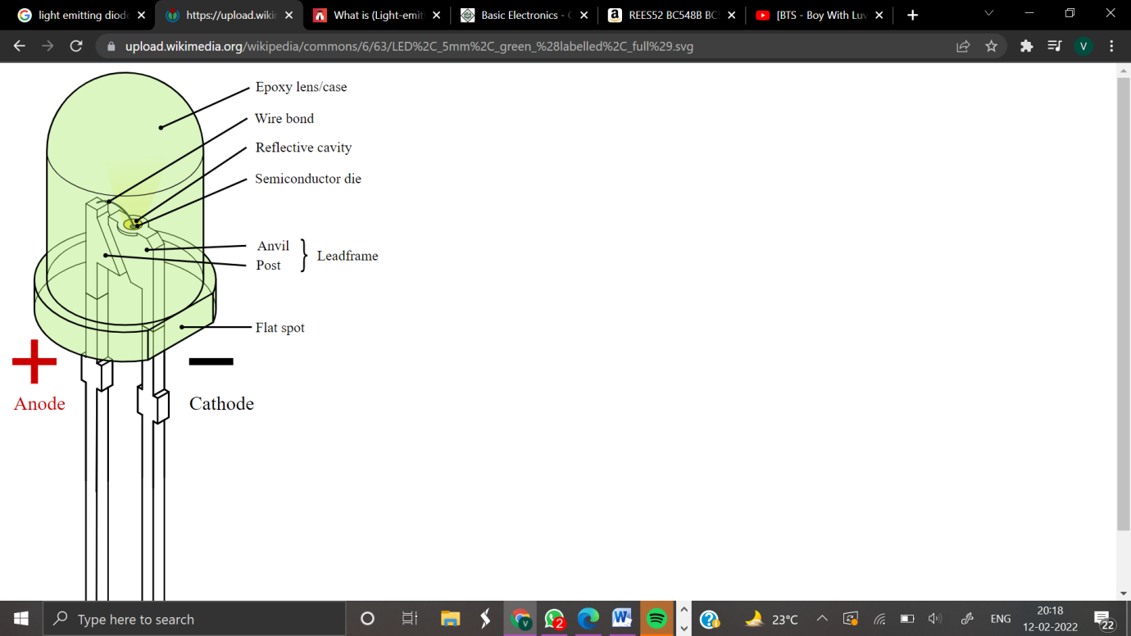

Fig.:2.e LED STRUCTURE

LEDs present many advantages over traditional light sources including lower energy consumption, longer lifetime, improved robustness, smaller size an faster switching. However, they are relatively expensive and require more precise current and heat management than traditional light sources. Applications of LEDs are diverse. They are used as low-energy indicators but also for replacements for traditional light sources in general lighting, auto motive lighting and traffic signals. The compact size of LEDs has allowed new text and video displays and sensors to be developed, while their high switching rates are useful in communications technology .

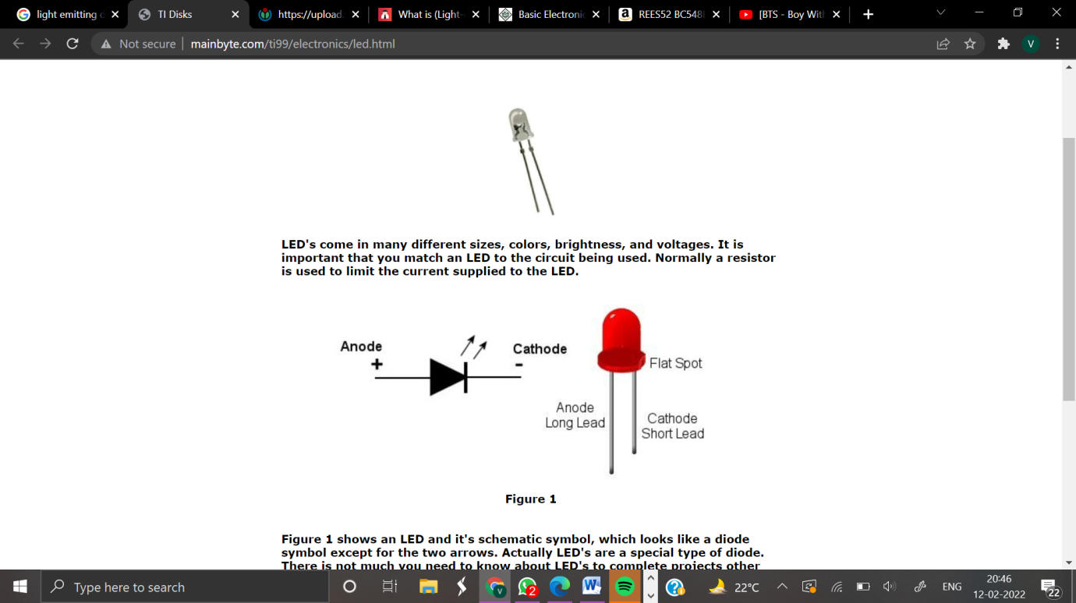

Fig.:2.e-1 LED

**2.2.5 IC CA3130**

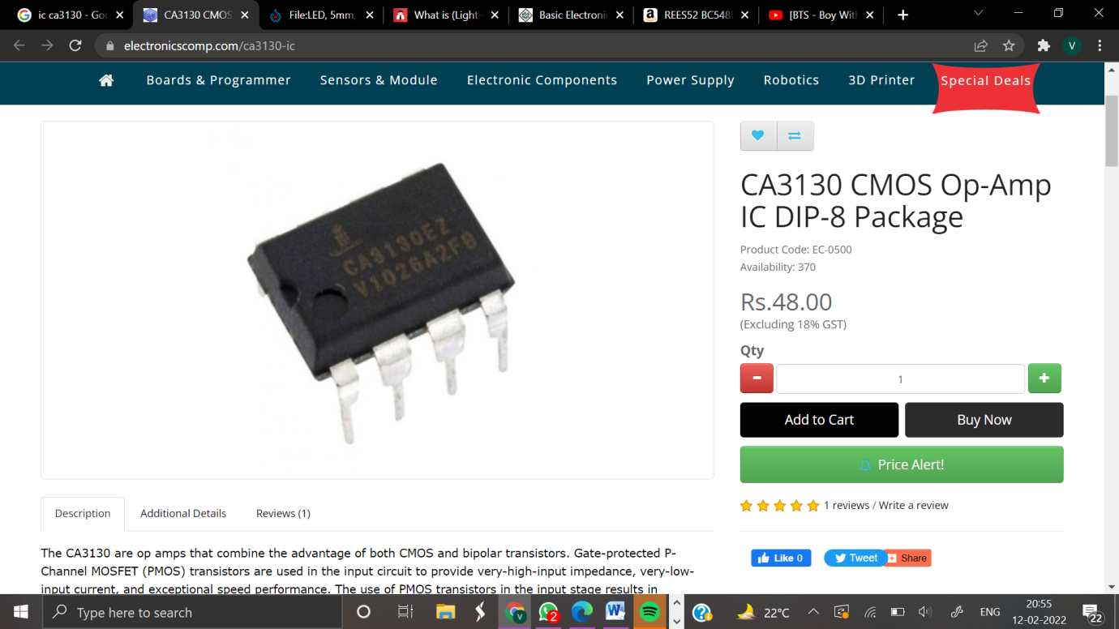Fig.:2.f IC CA3130

IC CA3130 This IC is a 15MHz BiMOS Operational amplifier with MOSFET inputs and Bipolar output. The inputs contain MOSFET transistors to provide very high input impedance and very low input current as low as 10pA. It has high speed of performance and suitable for low input current applications. CA3130A and CA3130 are op-amps that combine the advantage of both CMOS and bi polar transistors. Gate-protected P-Channel MOSFET (PMOS) transistors are used in the input circuit to provide very-high-input impedance, very-low-input current and exceptional speed performance. The use of PMOS transistors in the input stage results in common-mode input-voltage capability down to 0.5Vbelow the negative-supply terminal, an important attribute in single-supply applications. A CMOS transistor-pair, capable of swinging the output voltage to within10mV of either supply-voltage terminal (at very high values of load impedance), is employed as the output circuit. The CA3130 Series circuits operate at supply voltages ranging from 5V to 16V, (2.5V to 8V). They can be phase compensated with a single external capacitor , and have terminals for adjustment of offset voltage for applications requiring offset-null capability. Terminal provisions are also made to permit strobing of the output stage. The CA3130A offers superior input characteristics over those of the CA3130.

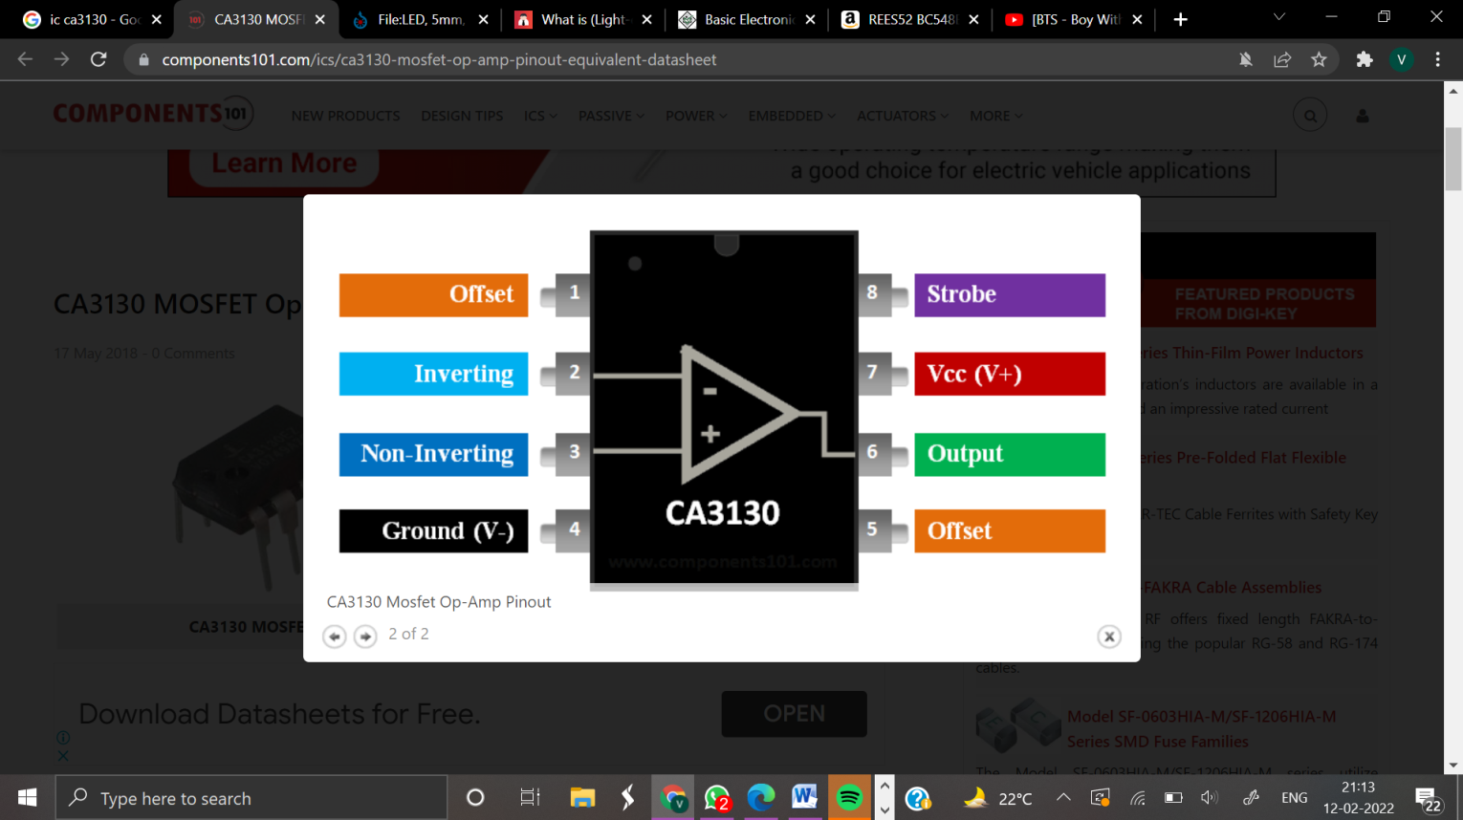  
FEATURES:

• MOSFET Input Stage Provides:- Very High ZI=1.5T-Very Low current = 5pA at 15V Operation

•Ideal for Single-Supply

APPLICATIONS:

•Common-Mode Input-Voltage Range Includes Negative Supply Rail; Input Terminals can be Swung 0.5V Below Negative Supply Rail

•CMOS Output Stage Permits Signal Swing to Either (or both) Supply Rails Applications

•Ground-Referenced 8Single Supply Amplifiers

•Fast Sample-Hold Amplifiers

•Long-Duration Timers/ Monostable

•High –Input Impedance Comparators (Ideal Interface with Digital CMOS)

•High-Input-Impedance Wideband Amplifiers •Voltage Followers (e.g. Follower for Single-Supply D/A Converter) •Voltage Regulators (Permits Control of Output Voltage Down to 0V

**2.2.6 PCB**

A printed circuit board (PCB) is a laminated sandwich structure of conductive and insulating layers. PCBs have two complementary functions. The first is to affix electronic components in designated locations on the outer layers by means of soldering. The second is to provide reliable electrical connections (and also reliable open circuits)between the component's terminals in a controlled manner often referred to as PCB design. Each of the conductive layers is designed with an artwork pattern of conductors (similar to wires on a flat surface) that provides electrical connections on that conductive layer, while an other manufacturing process adds via-small and precisely located holes that are drilled through the laminate and then plated with copper .The vias are the electrical inter connection between layers that are otherwise insulated in the laminate structure and this allows a third dimension of connection between conductive layers in a controlled manner that is both reliable and cost-effective for mass production of electronic products



Fig.:2.g PCB

Advantages of PCB:

Excellent shelf life. This board gives low electronics noise. Compact size and saving of wire. Inspection time is reduced because PCBs eliminates the probability of error. This board takes less time in assembling a circuit as compared to the conventional method.

**CHAPTER-3**

**HARDWARE IMPLEMENTATION**

**3.HARDWAREIMPLEMENTATION**

**3.1 Basic principle and working of mobile phone detector**

PURPOSEOFTHECIRCUIT:

This circuit is intended to detect unauthorized use of mobile phones in examination halls, confidential rooms etc… It also helps to detect unauthorized video and audio recordings. It detects the signal from mobile phones even if it is kept in the silent mode. It also detects SMS.

CONCEPT:

Mobile phone uses RF with a wavelength of 30cm at 872 to 2170 M Hz. That is the signal is high frequency with huge energy. When the mobile phone is active, it transmits the signal in the form of sine wave which passes through the space. The encoded audio/video signal contains electromagnetic radiation which is picked up by the receiver in the base station. Mobile phone system is referred to as “ Cellular Telephone system ”because the coverage area is divided into “cells” each of which has a base station. The transmitter power of the modern 2G antenna in the base station is 20-100watts. When a GSM(Global System of Mobile communication) digital phone is transmitting, the signal is time shared with 7 other users. That is at any one second, each of the 8 users on the same frequency is allotted 1/8 of the time and the signal is reconstituted by the receiver to form the speech.

Peak power output of a mobile phone corresponds to 2watts with an average of 250 milli watts of continuous power. Each hand set within a “cell” is allotted a particular frequency for its use. The mobile phone transmits short signals at regular intervals to register its availability to the nearest base station. The network database stores the information transmitted by the mobile phone. If the mobile phone moves from one cell to another, it will keep the connection with the base station having strongest transmission. Mobile phone always tries to make connection with the available base station. That is why ,the back light of the phone turns on intermittently while traveling. This will cause severe battery drain. So in long journeys, battery will flat within a few hours. AM Radio uses frequencies between 180 kHz and 1.6 MHz, FM radio uses 88 to180MHz, TV uses 470 to 854MHz. Waves at higher frequencies but within the RF region is called Microwaves. Mobile phone uses high frequency RF wave in the microwave region carrying huge amount of electromagnetic energy. That is why burning sensation develops in the ear if the mobile is used for along period. Just like a microwave oven, mobile phone is cooking the tissues in the ear. RF radiation from the phone causes oscillation of polar molecules like water in the tissues. This generates heat through friction just like the principle of microwave oven. The strongest radiation from the mobile phone is about 2 watts which can make connection with a base station located 2to3 km away.

HOW THE CIRCUIT WORKS?

Ordinary LC (Coil-Capacitor) circuits are used to detect low frequency radiation in the AM and FM bands. The tuned tank circuit having a coil and a variable capacitor retrieve the signal from the carrier wave. But such LC circuits cannot detect high frequency waves near the microwave region. Hence in the circuit, a capacitor is used to detect RF from mobile phone considering that, a capacitor can store energy even from an outside source and oscillate like LC circuit.

USEOFCAPACITOR:

A capacitor has two electrodes separated by a “dielectric” like paper, mica etc. Then on polarized disc capacitor is used to pass AC and not DC. Capacitor can store energy and pass AC signals during discharge 0.22µF capacitor is selected because it is a low value one and has large surface area to accept energy from the mobile radiation. To detect the signal, the sensor part should be like an aerial. So the capacitor is arranged as a mini loop aerial (similar to the dipole antenna used in TV). In short with this arrangement, the capacitor works like an air core coil with ability to oscillate and discharge current.

HOWTHECAPACITORSENSESRF?

One lead of the capacitor gets DC from the positive rail and the other lead goes to the negative input of IC1. So the capacitor gets energyfor storage.This energy is applied to the inputs of IC1 so that the inputs of IC are almost balanced with 1.4volts. In this state output is zero. But at any time IC can give a high output if a small current is induced to its inputs. There a natural electro magnetic field around the capacitor caused by the 50Hzfrom electrical wiring. When the mobile phone radiates high energy pulsations, capacitor oscillates and release energy in the inputs of IC. This oscillation is indicated by the flashing of the LED. In short, capacitor carries energy and is in an electromagnetic field. So as light change in field caused by the RF from phone will disturb the field and forces the capacitor to release energy.

3.2APPLICATIONS:

•It can be used to prevent the use of mobile phones in examination halls, confidential rooms ,etc.

•It is also useful for detecting the use of mobile phone for spying and unauthorized video transmission.

•It is useful where the use of mobile phone is prohibited like petrol pumps and gas stations, historical places, religious places and court of laws

**CHAPTER-4**

**RESULTS**

**4.RESULTS**

4.1 HARDWARE RESULT:

The moment the Bug detects RF transmission signal from an activated mobile phone, the LED blinks.The LED blinks until the signal transmission ceases Result

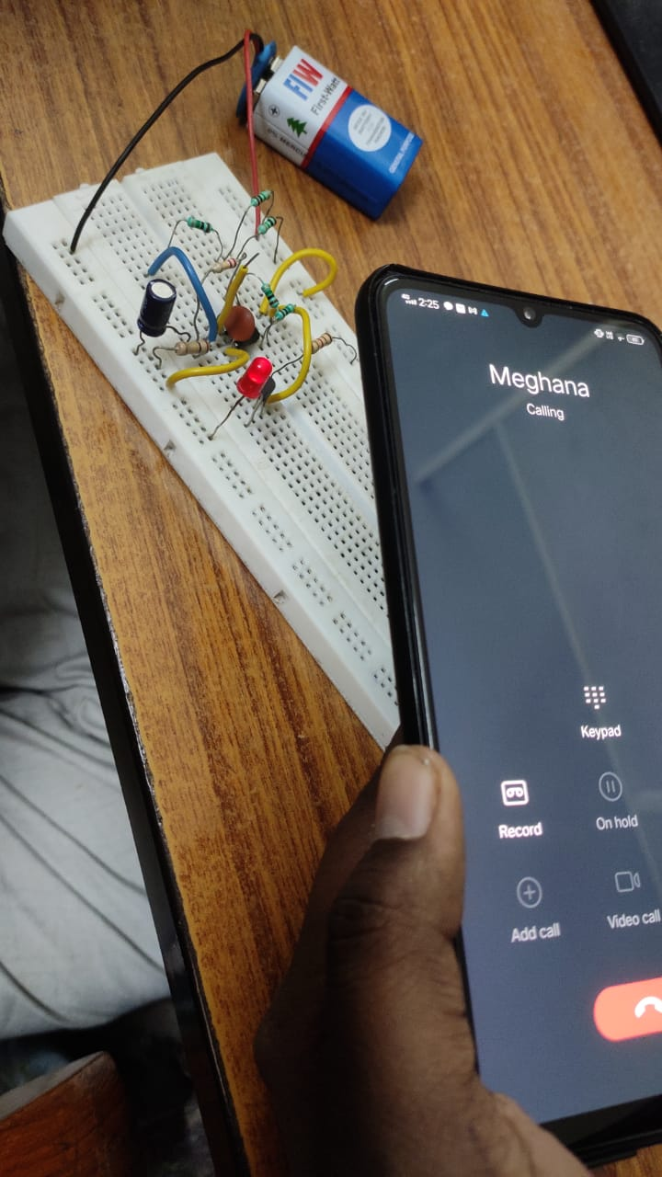

**4.2 FUTURE SCOPE**

Trying to increase the detecting range of cell phone detector to few more meters for observing wide range of area. The following are recommended to improve the functionality of this cell phone detector:-

(i)Increase the range of the detector.

(ii)Incorporate a buzzer to sound an alarm when a cell phone in use is detected.

(iii)Use of microcontroller to improve the detector.

(iv)Make the LED go off until a cell phone is in use.

(v)Improve the detector to be able to detect even cell phones on stand by mod

**CONCLUSION :**

This pocket-size mobile transmission detector or sniffer can sense the presence of an activated mobile cell phone from a distance of one and-a-half meters. So it can be used to prevent use of mobile phones in examination halls, confidential rooms etc. It is also useful for detecting the use of mobile phone for spying and unauthorized video transmission.